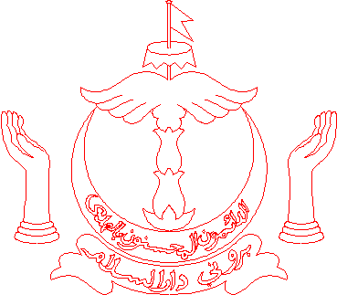

JABATAN ALAM SEKITAR, TAMAN DAN REKREASI
KEMENTERIAN PEMBANGUNAN

OPEN INVITATION FOR EXPRESSION OF INTEREST TO INVEST, DESIGN, DEVELOP AND OPERATE INCINERATION TECHNOLOGY OR WASTE TO ENERGY (INCINERATION) PLANT IN NEGARA BRUNEI DARUSSALAM (BRUNEI WTE).

REFERENCE NUMBER: JASTRE/BKP/EOI/01/2021

The Department of Environment, Parks and Recreation (JASTRe), Ministry of Development, wishes to invite interested parties to participate and submit proposal in the above Expression of Interest (“EOI”). Further details can be obtained by collecting the EOI document through:

Reception Counter at the following address:  Department of Environment, Parks and Recreation,  First Floor, Tumasek Plaza Building,  Jalan Raja Isteri Pengiran Anak Saleha,  Bandar Seri Begawan BA1910  Negara Brunei Darussalam | OR | Send an e-mail to request for the EOI document to sw.jastre@env.gov.bn with the subject heading:  EOI to “Invest, Design, Develop and Operate Incineration Technology or Waste to Energy (Incineration) Plant in Negara Brunei Darussalam (Brunei WTE)”.

To be eligible to register and collect the document, interested parties are required to provide information on the company’s brief profile, relevant experience and contact details. Completed submissions for the EOI document should be submitted:

In a sealed envelope and marked with the EOI Reference Number and project title as above and shall be addressed to:  Mini Tender Board, Ministry of Development,  Ground Floor, Ministry of Development Building,  Old Airport, Berakas,  Bandar Seri Begawan, BS3510,  Brunei Darussalam | OR | Via e-mail to:  ltk.mod@mod.gov.bn  (For International Companies only and further details can be obtained in the EOI document)

IMPORTANT DATES:
- Issuance Date of EOI: 4th May 2021 (Tuesday)
- Last Date of Collecting/Requesting EOI Document: 25th May 2021 (Tuesday)
- Closing Date of Submission: 15th June 2021 (Tuesday) before 2.00 pm

Reminder: Any registration / submission received later than the specified dates and time will not be entertained.

